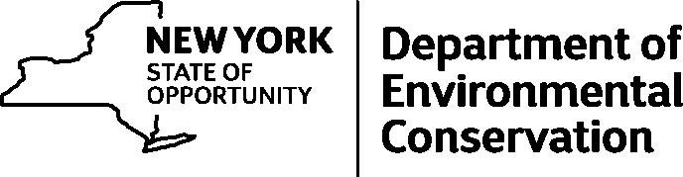
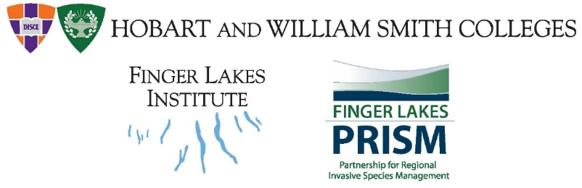

Agenda for October 28, 2019
Finger Lakes-PRISM Working Group Meetings
TIME: 1pm – 4pm
LOCATION: Finger Lakes Institute, 601 S. Main Street, Geneva, NY
Meeting Objective
To bring together members of the Finger Lakes region to discuss regional updates, new invasives on the horizon, and prioritization of invasive species

AGENDA

Welcome and introductions

Roundtable- partner and regional updates (opportunity for brief updates and discussion of regional topics, new funding sources, and support needs)

Finger Lakes PRISM project updates

Review of species priorities list and working group breakout- messaging- Tabled
Wrap-up and set next meeting schedule
Adjourn

Table of Contents
Pages
1 | Agenda for October 28, 2019 Finger Lakes PRISM Meeting
2- 5 | Minutes from March 2019 Finger Lakes PRISM meeting
6-10 | Working Group Purpose, Strategy, and Priority Invasive Species List
11 | Invasive Species Prioritization Project
12 | Invasive Species Tier Chart
13 | Finger Lakes PRISM Invasive Species Messaging

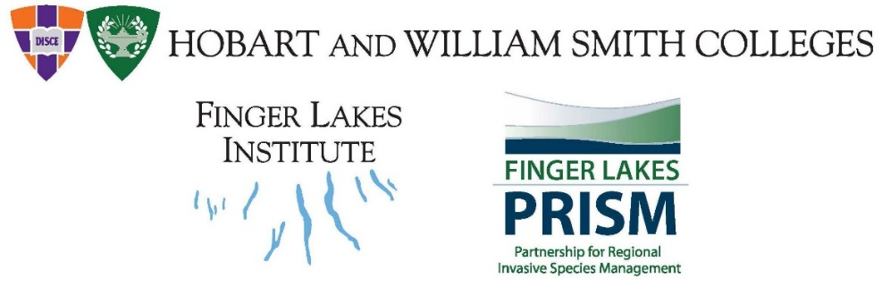

March 26, 2019

Finger Lakes-PRISM Working Group Meeting MINUTES
TIME: 10-2pm,
LOCATION: Finger Lakes Institute, 601 S. Main Street, Geneva, NY
Meeting Objective

To bring together members of the Finger Lakes region to discuss regional updates, new invasives on the horizon, separating IS issues with current political culture of #stoptheinvasionspread, and other IS issues

In attendance:

AGENDA

10:00 | Welcome and introductions
10:15 | Partner and regional updates (opportunity for brief updates and discussion of regional topics, new funding sources, and support needs)  Michele- IS working plan , Asian clam survey, Hydrilla, HWA is a problem, imap training  Chenga- 3 gorges project- 2 years, second year of project- preparing summer season- crew of 8 people in summer- manual removal- swallowrt, EDRR porceleinberry-2 lcoations in Buttermilk SP, Taughanock Falls, parternship meeting after the WG meeting,  Becky- NYSPARKS- working on HWA to work on spring treatments- hoping that we can get a nice dry, spring,  Laura- MFO- workshop and woods walks – Patty and Brittany to present at workshops- lake associations- grant for WCS program- shoreline survey volunteers are out once per week- IS- in their zone areas-  Patty – EO- SLF- lots interesting information- consistent messaging- MFO programming in the FLX- macrophyte survey- working with lakeshore monitoring- three high priority species- kits available- scout girls- Song lake in Tully STEM IS teach them about IS- dig  Cindy- retired as an entomologist- CLWA as a volunteer- HWA phenology project- checking for egg laying on west side of Canadice Lake- helping the colonies- Wrote up an article for CLWA- Weekly until they start laying eggs- estivation break- working with HABS currently, was a former WCS-  Kyle- Work for NYSPARKS #FLX upcoming field season planning- work reports- controlling invasive shrubs in a floodplain- worked in all the floodplains- work in 160 acres- will be wrapped up- submitted a grant for continued work here and a grant at HHS- control IS- Curious to know about this new invasive Rubus caesius- looks like blackberry- doesn’t produce much fruit- flooding- rhizomatically spread- a few reports in botanical journals- has been ranked- underleaf is not white- likely – fall is a good time for this one- scenesces later than other raspberries- big green clumps in fall- Monitoring at 3 Gorges project- native plants in HHS on August 3rd-  Thom – been in position for 6mo- IS coordinator for Ag and Mrkts- connecting with the PRISMs- position vacant for 7years- here now- be here 2-3x per year participation- contact person for the Dept- also involved with SLF response- logistics section chief- gets lot of ‘stuff’- finds it, gets it, distributes it- resource needs? Ask Thom- issues- Part 575 regulations- violations of shipping of prohibited plants and animals- labeling an issues- nursery shipping plants in should have the labels- or shipped in with them-  Pat- Forester with NYSDEC- private lands in Yates and Chemung Counties- region- control work for OW in Bristol- got all the control work- treated stumps with herbicide- 12 trees were taken down- 3 were tested positive for OW- root grafting- trenching- each of landowners did trenching and chipping, tree removal- quarantine zone by commissioners 46 landowners- can’t move oak material offsite unless it has been chipped to 1” and no firewood to be moved- surveying this summer- eight people for GH out of Avon- 2 interns out of Bath office- forest health division- Brice June has been managing the OW, Gooding helping too. – lighted sign at NYSDEC Albany- EAB funds (was purchased)- port of Albany- Patrick Eager NYSDEC PPQ- monitors use agreement- who owns lighted sign?  Don- COFOKLA- northern end of Cortland Co. and S. end of Onondaga County- partner with Corltand SWCD- 4th year of WCS program- applied for grant program- outreach programs this summer- BMPs- identified in technical capacity grant from NWFWF- riparian buffers- funding from USC- Central NY FOLA conference- Target 150 people- 10 counties- target spp- individual lakes- HABs- little yoke- variable leaf milfoil- herbicide treatment- privately funded- riparian owners- county funding a little- 18 acres- $18-$20k cost. Little York lake- attempted herbicides a few years ago- constrained as to which products to use- Cazenovia Lake used certain herbicide and it traveled – changes in policy allowed Navigate 2FD- previously prohibited- NYSDEC reevaluated- milfoil dominates so redefined use-  Dave- managing the SSW collaborative new for FLI- collaborative is Great Lakes basin- circle the wagons across the basin- group of expert panels – 8 people who are experts from across the region- growing # of collaborators who conduit to the local level- to the citizens on the ground- look at NAS to report and iMapInvasives. Experts guide the program- in other states SSW has been researched for decades- NYS- not really researched- building a contacts list if you want to be on the list. Did a webinar overview of the program- audio recording of the program- next webinar will be in June- from expert panel from WI and MN- describing their training program- focusing on the outreach to pilot a survey program- how to identify SSW – how to get a big region but start small? Starry Trek- AIS snapshot will occur in August-  Kate- previously managed WC control project- last year field totals – information is passed around from project around region- transitioned to Hydrilla- applied for additional funding to WC control- Treatment for infestations found- USACE helping with the Aurora project- survey for this coming season- LO Embayments- owasco lake potentially this season- a lot of E&O for this project, trainings- teachers, volunteers, etc.  Jon- NYSDOT- planning for the planting season- work with subcontractors- make sure that plants have been inspected – screen projects while in design for any IS- to prevent the spread of IS- phrag, swallowwort, bittersweet are big concern on projects-  Carri – IS Specialist, Cornell- HWA and for Ag weeds- busy winter with lots of trainings in the FLX- hard to find HWA this winter- lot of summer mortality- hard to identify this year- release sites for biocontrol- protected areas with lots of HWA and trees- mark is out collecting food for the spring predator- winter predator- larvae is starting to pupate- working on two other projects- ag weed ID project- better materials for targeted ag community- working with crop advisors- interest in this area of work- let Carri know- found palmer ameranth working on herbicide testing- it’s a pigweed- found in Ontario County- comes in on equipment- water hemp- pigweed family oddball species- websites and materials- community that would be interested in training, let Carri know. Contact perennial or urban growers- Walt Nelson had a list of growers-  Brittany- IS project coordinator for FLI- put together the IS management guide- life history- propagation, seed banking potential- brief description of plant, phenology, lookalikes, management options, etc. planning guide- seasonal options. Education and outreach events for NYSDOT and CCE MFO-  Bruce- FLCC- recently retired repurposed- field station- spotted salamander migration time- 1300 rescued- this Thursday looks to be good too! Might get a couple thousand spotted salamanders to rescue- walk in early August at HHS- no barbed wire- no IS in this area- there was chestnut blight- hemlocks were 170 yrs old- SLF training session- Thursday, April 18, FLCC Viticulture Center- Tim Weigle is running program- flyer to be sent.
11:15 | Finger Lakes PRISM project updates
11:30 | Update on de-politicizing IS outreach efforts  Background- my awareness came from other campaigns were on billboards- all of our minds are part of IS world, other people are not aware- immediate associate with politics- not pushing a political agenda intentionally, but if not careful, we are unintentionally pushing an agenda-  #stoptheinvasion is an antiimmigration hastag- handouts spread this message that may lose its value upon spread- our message doesn’t want people to feel unsafe.  Met with Causewave in Rochester- formally the Ad Council of Rochester, there are professional communicators- can come up with a campaign better than we can- probably a bigger campaign that will be launched in 2020- play clean go- isn’t necessarily invasive speices, but other campaigns do-  NYSDEC has a working group on EO and branding- not something that can be changed overnight- avoid using the work ‘stop’- facebook and Instagram and Tweets- #FLPRISM #NYISAW- contest- most people – contest- post pictures with this hashtag- more generic- experience using a hastag- engender use- show a picture of you doing something- hashtags are powerful search tools-
12:00 | Break for lunch and stretch (Bring your own lunch)
12:30 | New invasives on the horizon: SLF and other high priority invasive species updates-  NYS response is a combined effort between all agencies- NYSIPM, PRISMS, DEC, AgMkts, ICS – adapted from military to fight fires in AZ- realized a communication gap was there- therefore, states and federal and local govts get training in ICS- management term- Thom gets stuff- everyone has a role- plug people in from various roles- changing roles for this structure- virtual response because people are everywhere- difficult job to manage all these roles- evaluate things are they go on- rotate positions-  Response plan is being revised currently- incorporating this information based on people in survey- taking information and response- final edits currently- hopefully this will be approved in the coming days- USDA CEPHIS(?) survey model based on transportation corridors and human populations- revised model includes recreation activities and camping, airBandBs, lot of people traveling – these pathways are being incorporated into this model- survey and regulatory- DOT weigh stations along NY/PA and NY/NJ target 8-12 sites checking the manifests- taking a look at the vehicles- found one in the grill of a truck coming from PA! following up by checking warehouses that came from PA. warehouse inspections- checking nursey stock- also stoneyards- targets stoneyards because they love this material- survey area of 1km grids- 13 separate regulatory incidents where SLF was found- no nymphs found- one adult found in a vehicle. Eggs on nursery stock in Westchester Co. resurvey this area- nursery in LI found SLF, none were viable. Resurvey areas and update model to incorporate this risk. Public outreach is a huge aspect of this program- apples, grapes, nursery- make recordings for these webinar. Emma Antolos- E&O coordinator and E&O with ICS. Will likely find an established population this season. We are pretty well prepared for when it arrives.  The five states- DE, NJ, PA, MD, VA
1:00 | Regional programming for NYISAW and community science projects
1:45 | Wrap-up and set next meeting schedule
2:00 | Adjourn
Spread!
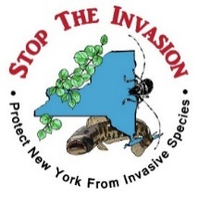

Finger Lakes - Partnership for Regional Invasive Species Management

Working Group Purpose, Strategy, and Priority Invasive Species List*

Steering Committee (SC)

Purpose:
To guide the 5-yr strategic planning process, plan and set overall direction for priority areas and IS and ensure that major goals and timeline are achieved. Set annual work plan and monitor progress, which may include tracking timelines and evaluation procedures. Provide strategic direction and coordination for the four working groups and serve as a liaison for the NYS IS Council and IS TF

Structural Statement
The steering committee will be made up of representatives from the Finger Lakes PRISM with an interest in the mission of the FL-PRISM. The working groups represent the larger stakeholder group. The structure of the PRISM, the steering committee and working groups is designed to ensure equality in decision-making for the Finger Lakes region (see structure document).

Strategies to accomplish purpose:
- To develop bylaws
- Establish a good working relationship with partners and working groups.
- Work in partnership with the working groups to develop priorities such as key invasive species to monitor and control, and locations in the FL region.
- Adopt a monitoring strategy for IS in the FL-region based on the outcomes from the WGs
- Adopt an Early Detection Rapid Response (ED/RR) plan that will help communities detect and respond to IS coming into the region, based on outcomes from the WGs.
- Develop the annual and work plan that brings together various stakeholders to establish the synergy necessary to tackle IS within the community through clear and concise strategies for prevention, control and remediation
- Help communicate the priority list and methods of introduction, which will include information about vectors of transmission, information about where IS are coming from and where they will go to be disseminated via FL-PRISM website.
- Develop a marketing and communication strategy, including a robust and all-inclusive website, to enable the community to recognize and consider FL-PRISM as the entity for information, management ideas, ED/RR, and all things invasive in the region providing a key element for citizen science or community members to submit their questions or early detection organisms- Report invasive species sighting utilizing tools such as iMap, or reporting fields to identify IS
*Developed and approved by the FL-PRISM working groups and Steering Committee, fall 2014.

Agricultural Working Group (AgWG)

Purpose of Agriculture Working Group:
- To create agriculture- specific priorities for invasive species management and prevention, determine highly probable locations and conditions appropriate for invasion and develop agricultural invasive species management plan. This working group will develop an agriculture-focused work plan, support best management practices intended to reduce or control invasive species, and support the steering committee as needed.

Strategies to accomplish purpose:
- Establish good working relationships with partners such as farmers, Cornell, DEC, Ag and Markets, and others.
- Working in concert with the E&OWG and the SC, determine the target audience in order to provide an Ag IS-specific toolbox with items to effectively and efficiently educate people about the impact of Ag IS and how to detect, prevent, mitigate and report Ag IS.
- Develop or identify a monitoring strategy, including monitoring protocols, for Ag IS in the FL-region
- Create an ED/RR plan that will help communities detect and respond to Ag IS coming into the region.
- Develop or identify a mitigation strategy with best management practices to mitigate impacts and help farmers deal with impacts.
- Develop or identify a prevention, management and work plan that brings together various stakeholders to establish the synergy necessary to tackle Ag IS within the community through a clear and concise strategies for prevention, control and remediation
- Develop or identify a protocol for the FL-region to deal with Ag IS issues at locations such as hedgerows, fallow field, etc. to provide consistent and clear messaging.
- Develop or identify a priority list and methods of introduction, which will include information about vectors of transmission, information about where Ag IS are coming from and where they may go, and how to prevent them to be disseminated via FL-PRISM website.
- Synthesize and disseminate data to the public via the FL-PRISM website.
- Create material on priority Ag IS for the FL-region (fliers, handbooks, datasheets, etc.).
- Establish the FL-PRISM website as the premiere location for all information on invasive species.
Develop a matrix to use when determining priority organisms and locations for IS invasion and management.

Priority invasives of concern:

Plants
- Autumn and Russian olive
- Canada thistle
- Field bindweed
- Japanese knotweed
- Johnson grass
- Ragweed
- Spotted knapweed
- Swallow-wort
- Velvet leaf
- Wild parsnip

Diseases
- Basil downy mildew, Peronospora belbahrii
- Grape crown gall, Agrobacterium tumefaciens
- Late blight, Phytophthora infestans
- Phytophthora blight, Phytophthora capsici
- Plum pox virus, Potyvirus

Insects
- BMSB (Halyomorpha halys)
- Garlic bloat nematode (Ditylenchus dipsaci).
- Golden nematode (Globodera rostochiensis) - not an insect but should be included
- Spotted wing drosophila (Drosophila suzukii)
- Swede Midge (Contarinia nasturtii)

Aquatic Working Group (AWG)

Purpose of Aquatic Working Group:
- To develop aquatic- specific invasive species priorities, determine highly probable areas, create an aquatic invasive species management, and work plan.
- The AIS working group will help in the prevention of new invasive species into the region, focus on early detection/rapid response of AIS, and support the steering committee as needed.
- The AWG and FL-PRISM will serve as the direct point of reference for AIS and establish a simple and effective means for preventing, detecting, reporting, controlling, and managing priority AIS of concerns
- To develop a robust website that serves as a clearinghouse for AIS issues (prevention, detection, response, management, control) in the Finger Lakes region.
- A secondary focus of this working group will be on the containment and management of established invaders within the region and provide information about conferences, workshops, and literature to the E&O WG.

Strategies to accomplish purpose:
- Establish a good working relationships with partners such as NYS OPRHP, DEC, NYSFOLA, and others
- Develop protocols for lakes without stewards.
- Working in concert with the E&OWG and the SC, determine whom the FLPRISM target audience is and how to provide an AIS-specific toolbox to effectively and efficiently educate people about the impact of AIS and how to detect, prevent, mitigate and report AIS.
- Develop a monitoring strategy, including monitoring protocols, for AIS in the FL-region
- Create an ED/RR plan that will help communities detect and respond to AIS coming into the region.
- Develop a mitigation strategy with best management practices to mitigate impacts and help communities deal with impacts.
- Develop a prevention, management, and work plan that brings together various stakeholders to establish the synergy necessary to tackle AIS within the community through a clear and concise strategies for prevention, control, and remediation.
- Develop a protocol for the FL-region to deal with AIS issues at locations such as boat launches, marinas, etc. at all the waterbodies in the region to provide consistent and clear messaging (Lake Ontario, Sodus Bay, Finger Lakes, Oneida Lake, Erie Canal, small glacial lakes).
- Develop a priority list and methods of introduction, which will include information about vectors of transmission, information about where AIS are coming from and where they may go, and how to prevent them to be disseminated via FL-PRISM website.
- Synthesize and disseminate watercraft steward/boat steward data to the public via the FL-PRISM website.
  - Develop a consistent marketing strategy to convey the importance of watercraft stewards to the public (i.e., Clean, Drain, Dry!, Stop Aquatic Hitchhikers!)
- Create material on priority AIS for the FL-region (fliers, handbooks, datasheets, etc.).
- Establish the FL-PRISM website as the premiere location for all information on invasive species.
  - I.e., create a simple spreadsheet with highlighted AIS where the public can click and find a simple page with the biology and information regarding which waterbody has infestation. Public can determine the highly probable areas (HPAs) of the area, etc. This will help to clarify and provide information on experts, points of contact for species of concern, legislation enacted, etc.
- Develop a matrix to use when determining priority organisms and locations for AIS invasion and management.
  - Create information about regional AIS and then lake-specific AIS

Priority areas:
- Boat launches
- Primary inlets and tributaries
- Marinas and bait shops
- HPA

Priority invasives of concern:

- Macrophytes
  - Hydrilla
  - Trapa natans (water chestnut)
- Macroalgae
  - Nitellopsis obtuse (starry stonewort)
- Invertebrates
  - Corbicula fluminea (Asian clam)
  - Hemimysis (bloody red shrimp)
- Fish and Fish Diseases
  - Web to send list of fish diseases to group
  - Neogobius melanostomus(round goby)
- HABs—is there a need to put this information on the website? Reach out to SUNY Buffalo to see about Asian clam connection HABs

Education and Outreach Working Group (E&OWG)

Purpose of the Education and Outreach WG:
- To establish a strong connection between FL-PRISM and the general public, volunteers, institutions of higher education, NGOs, agencies and other stakeholders.
- To promote FL-PRISM in a way that fosters awareness of our mission; generates interest in being a partner; enhances visibility within agencies, and the Finger Lakes region to increase general knowledge (detection, prevention, control) of invasive species.
- The E&O WG will educate the Finger Lakes community on invasive species issues and provide the tools necessary to make sound management decisions.
- The E&O WG will determine appropriate means for education and outreach based on resources available.
- The E&O WG also seeks to demonstrate to the general public and others the mutual benefit of investing human and economic resources in the FL-PRISM.

Strategies to accomplish purpose:
- Generate and increase invasive species awareness and education within the FL-PRISM
- Create a network of information sharing for marketing collateral and resource sharing across the FL-PRISM
- Create a strong web-presence for the FL-PRISM E&O to include necessary resources for managers, general public, lake associations, etc. on dealing with invasive species- flow chart
- Create fact sheets and information for professionals and educators
- Develop a list of venues/events to offer opportunities to raise awareness about the FL-PRISM and invasive species
- Sponsor education and outreach conferences, symposiums and public forums to increase invasive species awareness across the region
- Offer technical training on IS identification and management options for professionals and educators in the region
- Create a list of experts in the field to draw upon for a speaker series- who is doing what (GAP analysis)
- Support the Agric, Aquat, and Terrest WGs to ensure that their priorities and products are delivered to the general public and the FL-PRISM
- Develop a process to ensure that FL-PRISM publications are consistent and appropriate for the region (vetted through Steering Committee)

Terrestrial Working Group (TWG)
Purpose of Terrestrial Working Group:
- To guide terrestrial- specific invasive species priorities, determine highly probable areas for invasion and engage in invasive species research
- The TWG will develop a terrestrial-focused work plan and invasive species management plan.
- The TWG will assist in the prevention of new invasive species into the region, focus on early detection/rapid response of invasive species and support the steering committee as needed.
- A secondary focus of this working group will be on the containment and management of established invaders within the region and provide information on terrestrial invasive species of concern, conferences, workshops, and literature to the E&O committee.
- Engaging in regional research on terrestrial invasive species (TIS)
- Promoting the FL-PRISM as a central clearinghouse for TIS

Strategies to accomplish purpose:
- Prevent new invasions through rapid detection and remediation of new invasions of plants
- Manage invaded areas
- Promote native planting (i.e., as landscaping) thereby decreasing potential for invasion
- Collaborate and network with regional invasive species educational institutions
- Inventory, survey and map populations of invasive plants
- Restore sites where weed management and control have occurred
- Monitor changes and evaluate management results

Priority areas:
- Areas where the infestation is low on the invasion curve and our effort can make a difference—i.e., Japanese knotweed in the Natl Forest is very low abundance
- Easily accessible areas for recreation where the plant can be spread—highly probably areas (HPAs) for invasion
- Edge of ecological important communities
- Transportation corridors/right aways

Priority invasives of concern:

- EAB
- Hogweed
- HWAJapanese knotweed
- Oriental bittersweet
- Swallow-wort (pale and black)
- Wild parsnip

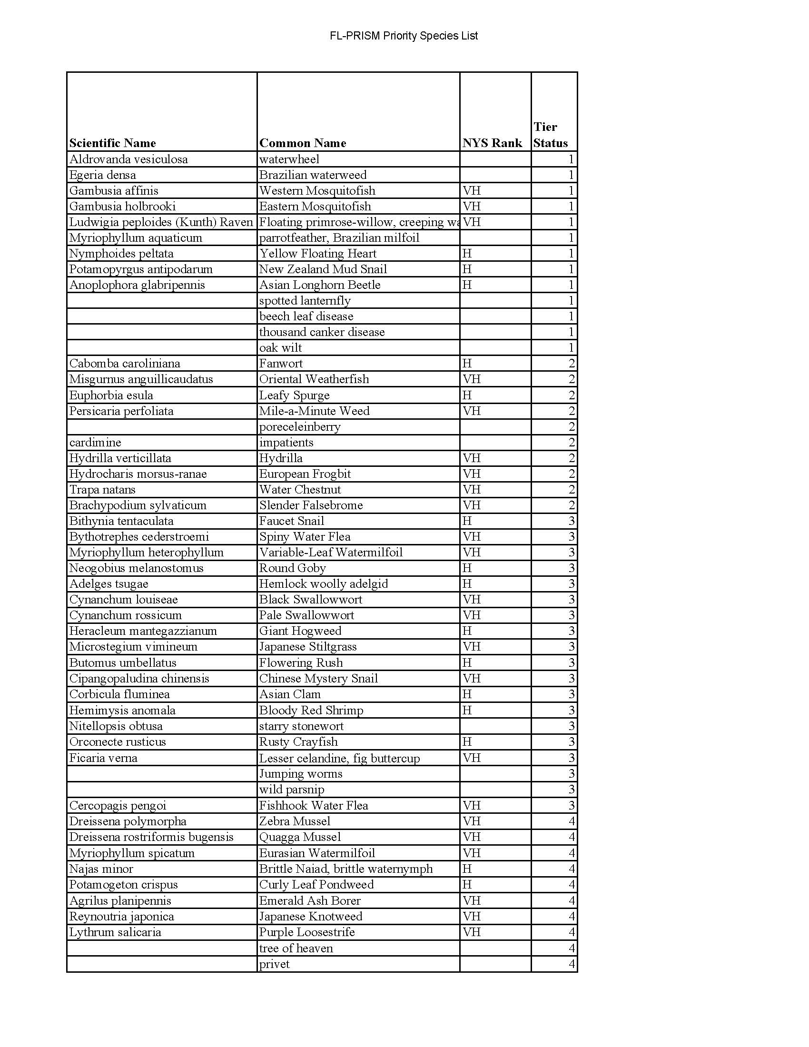

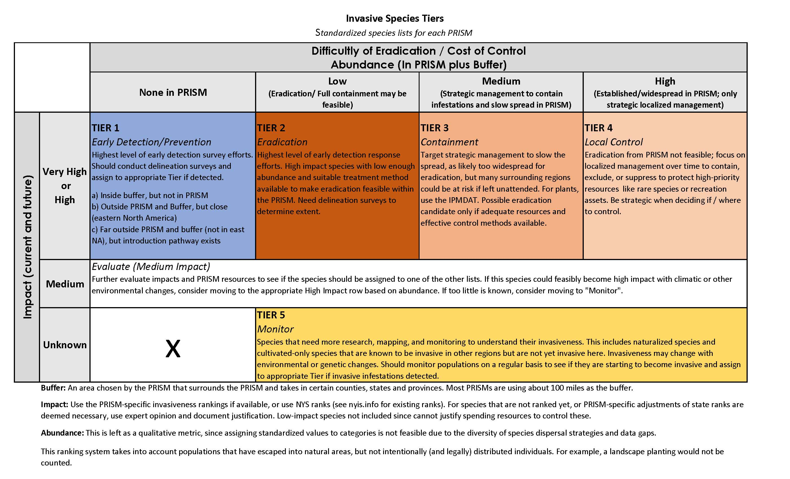

Finger Lakes PRISM Working Group
Invasive Species Messaging DRAFT Comments and Ideas

Goal: In light of the co-option of invasive species messaging by various political campaigns and the ongoing conflation of invasive species work and xenophobia, modify our invasive species messaging to disentangle our message from anti-immigration messaging, clarify our focus on protection of existing species and ecosystem services, and the local impacts of invasive species rather than their origin.

Suggestions:

- Use the phrase “invasive species” instead of “invasives”
- Consider shifting to the phrase “community science” instead of “citizen science”: do we only want citizens?
- Emphasize the impacts of invasive species rather than their country of origin
  - If country of origin is included on fact sheets, etc., list it below information about impacts
  - If unsure of the origin of a species, explain that many of our invasive species come from Eurasia (rather than “Asia”) because we share a similar climate
  - When introducing the topic, mention that 99% of introduced plants are not considered invasive- it is about impact, not origin
  - Explain insect-plant/ ecosystem significance of native vs. introduced species as part of the explanation of prioritizing native species.
    - E.g., monarch caterpillars evolved with milkweed and are able to digest and utilize the toxins produced by milkweed, but cannot properly digest the toxins found in non-native swallowwort, which causes caterpillar mortality
- Point out that many of our native species are invasive in other countries.
  - Goldenrod is invasive in Europe and Asia
  - Ragweed is invasive in Europe and Asia and is a health problem
  - Poison ivy is invasive in Europe
- Use analogies that are unlikely to distance anyone in the audience
  - Zombies!
  - Medical- invasive species are a disease and we want to protect the body/ ecosystem
  - Consider whether analogies and slogans could be misconstrued out of context
    - “#stoptheinvasion is now primarily used as an anti-immigration message
    - Always provide context!
  - Emphasize protection of species/ ecosystems rather than killing of invasive species
  - Focus on specific, action-oriented directives
    - Clean, Drain, Dry
    - Play, Clean, Go
- Whenever possible, check in with people who may feel marginalized by our work/ rhetoric and get their feedback so that we can improve the clarity of our messaging.
  - This is the most important and hardest component on this list! There has been little of this, that we know of, so far, and it is a crucial piece.
- Remember- intention is irrelevant. If we are making others feel unsafe and unwanted in our outreach, it does not matter that our intentions were good.

