FL-PRISM Steering Committee Minutes
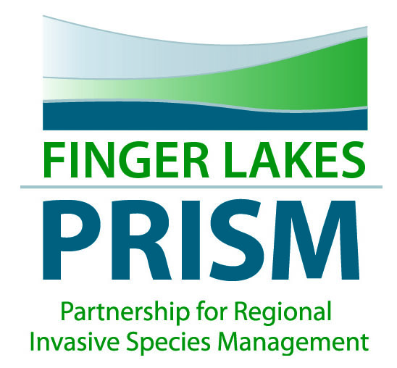
April 11, 2017, 11-1pm
Bring your own lunch!
Finger Lakes Institute, Geneva, NY

Attendees: Terry Gronwall, Dorothy Gronwall, Aimee Clinkhammer, Don Cook, Miranda Reid, Lisa Cleckner, Hilary Mosher
Absent:
- Welcome and meeting objective
- Review of minutes from January meeting
- Discussion of subcontracts for the 2017
  - Hydrilla survey in area waterbodies – macrophyte report for each area (Goal 1, 3)
  - Phenology of the plants in the area for management and volunteer emphasis (Goal 6)
- Strategic Plan Goal #5- Information Management and Communication- FL-PRISM will increase its capacity and partnership through information sharing and effective communication strategies.
  - Increasing the way that the FL-PRISM has a presence in the region as a communication hub for IS reporting and information sharing (see strategic plan below)
- Roundtable reports- partners provide updates
  - Miranda Reid- IS subcommittee meeting- working on watershed education center- committee working on that project- Town of Livonia- owns Vitale Park- replaced a few buildings with a community education center- working with partners to fill that with different outreach materials- monthly speaker series focused on WQ- Chip Holt Center for kids has programming- lake association does programming for May- Miranda to forward info on IS to Hilary for listserve- working on that- grants for stormwater study- Village of Livonia for shoreline restoration and rain garden programming- Working with Aimee on TMDL- work with FLPRISM to come up with a MAM management plan- mapping interns- has been a hard sell to address the watershed scale issue of MAM because of indirect relationship to water quality chemistry
  - Chris Anderson- FWS preliminary mussels are in two drainage areas- Waterford to Tonawanda- habitat for endangered mussels- is there a correlation between high IS- to low mussel abundance? Most streams are in the FL? List of tribs throughout the state- e.g., Salmon Creek- Chris to send a list of tribs and species to the group- reach out to FWS regarding survey work
  - Don Cook- wearing several hats- CSLAP initiative- talking about macrophyte survey- changing over to the CSLAP guidelines for survey of macrophytes- guidelines are more intensive than what is currently being taken-
- PRISM updates
  - Project updates
    - Hydrilla
    - ED/RR Species- Mile-a-minute and Oak wilt
    - Water chestnut
    - Giant hogweed
    - Ganondagan
  - Annual report
  - Funding update
- Other items of interest
  - Invasive Species Awareness Week
  - Spring Partner Meeting
  - Working group meetings- meetings to be held on April 21, FLI
- Adjourn
Next MEETING DATE/TIME: May 16th Steering Committee meets! Same day as the Full partner meeting! Let’s meet beforehand if possible? Or combine?

Goal 5: Information Management and Communication
FL-PRISM will increase its capacity and partnership through information sharing and effective communication strategies.
Objectives:
- The FL-PRISM will have a fully-utilized and robust web presence.
- The FL-PRISM and partners will develop and promote use of IS materials, protocols and fact sheets.
- The FL-PRISM will encourage IS reporting and information sharing.
- The FL-PRISM will create opportunities for partners to share information and resources.

Strategies:
- Partners utilize the FL-PRISM website for information on IS within the FL region and beyond and provide updates on IS content and events.
- Develop a marketing and communication strategy including a robust and all-inclusive website to enable the community to recognize and consider FL-PRISM as the entity for information, management ideas, ED/RR, and all things invasive in the region.
- Synthesize and disseminate IS education and surveillance data such as watercraft steward/boat steward data to the public via the FL-PRISM website.
- Develop a consistent marketing strategy to convey the importance of IS prevention to the public (i.e., Clean, Drain, Dry!, Stop Aquatic Hitchikers!).
- Develop a prevention, management, and work plan that brings together various stakeholders to establish the synergy necessary to tackle IS within the community through clear and concise strategies for prevention, control, and remediation.
- Develop a FL-PRISM resource guide for partners to include resources, capacity, and partner capabilities within the region.
- Develop a matrix to use when determining priority organisms and locations for AIS invasion and management.

Outputs:
- FL-PRISM website is utilized by the public and partners for IS information.
- Information about regional IS and location-specific IS is created and maintained based on partner input.
- Finger Lakes regionally-specific database for point of contacts for IS reports and information is created and maintained.
- Increase in number of FL-PRISM listserve subscribers per year.

Outcomes:
- The FL-PRISM is used as the resource in the area for information about biology, distribution, control measures, etc. of IS within the FL and the region.
- Partners recognize and utilize the FL-PRISM website as a source for information on IS.
- Partners share information and leverage resources.

