FL-PRISM Steering Committee Minutes
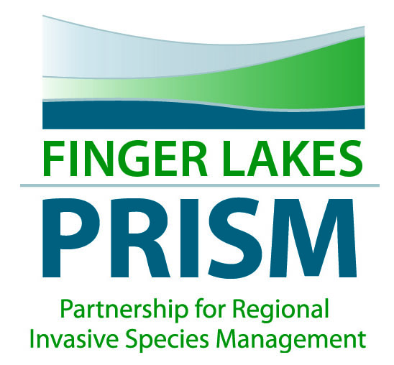
Feb 7, 2017, 11:00am-1:00pm,
Finger Lakes Institute, Geneva, NY
Meeting objective: Q3 update, 2017 RFP subcontract process, and updates from group

- Welcome and introductions
Miranda Reid, Emily Staychock, Don Cook, HVLA and NYSFOLA, FLRWA, Water resources council for Ontario County, Amee Clinkhammer- NYSDEC Hub Coordinator, Dorothy and Terry Gronwall- HL watershed Tasforce and HVLA, Carrie Marschner- Cornell U extension associative for NYS Hemlock Initiative
- Review of minutes from 11/14/16 meeting (pages 1-3)
- Strategic Plan Outputs and third quarter status update (pages 3-5)
- Annual work plan review for 2016 and proposed for 2017 (attached to email)
- Review of the RFP for the 2017 round of subcontract projects for the FL-PRISM (pages 5-10)
  - Competitive funding priorities (strategic plan goals)
    - Hydrilla survey in area waterbodies including macrophyte identification (Goal 1, 3)
    - Phenology of the plants in the area for management and volunteer emphasis (Goal 6)
- Roundtable reports- partners provide updates
  - Terry and Dorothy update- quagga mussels in Honeoye Lake-shifting focus to research into internal loading – polymictic-anoxic conditions release P- released NH4- did not reach surface until August – anabaena-dominated- Lake Symposium- second Saturday in June- working on agenda and speakers for this- Never founds Fe- should have Fe in samples- H2S- people can use tire chips to capture P- to promote Fe capture- Crushed glass to tie up P? Treewells- rain gardens to tie up the P- Chris to send articles on these programs- 4mi long, 30feet deep, 3/4mi wide-
  - Aimee- Hub began in the beginning of the year- Owasco lake and Cayuga Lakes will be the focus initially- help coordinate activities within Regions 7 and 8- watershed management plans for the lakes, coordinating dec response and working with stakeholders (watershed groups, I/O, etc.) engagement- Finger Lakes outreach, modeling, 3 additional technical staff (2 by March), 1 high level research scientist April/May- looking for ways to be helpful- gaps, etc. trial and error initially-
  - Don- Aimee participated in the FLRWA to engage partners with the FL- Don reached out to USACE- list of potential guest speakers- Mike coming to the next meeting for the FLRWA- October regional NYSFOLA Silver Lake- October 20- colleges to speak about their programs and engagement- NYSDEC to do an iMap training at this meeting-
  - Emily- KLA looking at SSW infestation at the Keuka Outlet- every boat that goes through the outlet is dragging the species throughout the FL- organize a thorough survey for SSW- Ryan S. and Emily had an oak wilt program Cheshire Fire Hall- CLWA helped- Environmental Conservation Board wants to survey for HWA- Bruce will survey those gullies in Cheshire- information to be sent to Carrie-
  - Miranda- IS committee looking at updating the prevention implementation section of the response plan- many of the strategies outlined are already in implementation- what new things can be done- work plan- pertaining to aquariums- I will connect you to Doug Verves, Cayuga Co. CCE, Environmental Management Council- HWA workshop for the community- stormwater and stream regulatory toolkit creation for outreach and programming- currently doing stakeholder interviews- meeting to follow with regulators to exchange info and then creation of final product. DOS- stormwater study in urbanized watershed- wilkin’s creek- 2015- Seagrant- shoreline restoration and green infrstratucture in Vitale park- shoreline working group- to encourage natural shoreline and restoration- $$ for engineering, public informational kiosks- public information center at this park- building a new building with new meeting space- mobile lab equipment- work together to do an educational programming- rain garden and rain barrels with new building- FLLOWPA- to finish the shoreline implementation- streambank remediation- APWA- environmental project of the year for this project. Updating the HAB brochure- looking to update watershed management plan- done 2004- looking to hire out a contractor with FLLOWPA. Hilary to connect with Miranda about the IS control grant for MAM- Aimee to look into funding for the update to the management plan for Conesus Lake
  - Chris and Rich- DOT- had questions for Aimee regarding the 9 element plan is similar to a TMDL- watershed management plan- EAB an issue- program changed to a great maintenance- notes to clean vehicles- enforcement is key- fighting a losing battle because eradication to the DOT right of way line- they have a consent order to clean out- they have phrag- hard to control- law of diminishing returns- Hilary to reach out to DOT regarding training opportunities- mowing contracts are informed regarding the spread and impact of invasive species-
  - Lisa- highlights of existing programs that will continue into next year- HAB- fluoroprobe on Honeoeye and deploy across the lakes to grounds truth data being collected- continuing Hg across lakes – 5-lake sutdu concluded recently- honeoeye vs. Seneca lake comparison study- Sam joinged for our WCS program- we can go over several years worth of data- 28000 in FL- 48,000 inspected across the region- 2.1 persons per boat- big opporuntities for education- stats and last water body visited- how much money are we spending versus other states and regions- student projects- economics major looking at P trading in FL watersheds- Fox River in WI- GreenBay- is green for a reason- how WWTP- pay for extra protection in farmland- unit of P has a dollar value- look at this for a model for the FL- SCD minor talking with Ontario Co for a county resiliency plan- grant app for DOS- water resources and resiliency- steep slopes- lots of cool- due the end of March- Seneca lake- watershed management plan- implementation plan with I/O- 5 counties 40 municipalities- sustainable funding models- welcome brainstorming opps for funding interesting models for stewards/manager/etc. Miranda to get information regarding funding model to Lisa- HABs across the FL from 2012-2015 lakes that watershed protection in place- have less HABs- instructive to look at the long-term data set- Conesus had one in June- and then a few in late Sept- Oct and Nov/Dec- one area in North end that is stagnant- heat is making the water to be warm enough to bloom in December- sits in the north end- big biomass- drones- people in Physics department- spectoroscopy- wavelengths- we’ve started looking at nearshore water quality- nutrient data- trying to extend this to SAV- how to detect a Hydrilla infestation below the water- collect more remote sensing data- all pilot phase- a lot of opportunities to deploy data- fluoroprobe and drone, and Honeoye and Owasco lakes- being drone footage-
- PRISM updates
  - Binder project
  - Grant updates
  - Priority IS updates
  - Working Group Updates
- Other items of interest
- Adjourn

Next MEETING DATE/TIME:
March 21, 11-1pm

