FL-PRISM Education and Outreach Working Group Agenda
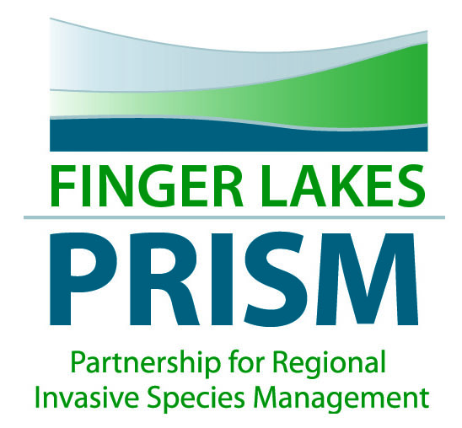

May 18, 9:00am-10:30am
Finger Lakes Institute, 601 S. Main Street, Geneva, NY
Join WebEx meeting

Meeting number: | 641 544 487
Meeting password: | F1ngerLakes

MEETING OBJECTIVE: partner updates/roundtable; discuss E&O needs for the region and summer priorities
- Welcome and meeting objective
- Review of minutes from January 21, 2016
- Summer priorities for E&O
  - Using iMapInvasives in outreach
    - Need for increased iMapInvasives trainings
  - NYISAW Events
- Tree and shrub giveaways- try to get native species, vet list by Steve Young, NYS Chief Botanist?
- Workshop opportunities/ speaker ideas
- Roundtable reports
- PRISM updates
  - E&O Interns for summer
  - EPA GLRI Water Chestnut Grant
  - NYSDEC AIS Prevention Grants
  - FLRWA
  - AIS update: Hydrilla update, water lettuce
  - TIS update: giant hogweed, Japanese knotweed, swallowwort, garlic mustard, bootbrushes,
- Other items of interest
- Adjourn
Next MEETING DATE/TIME: January, April, July, October—third Thursday of the quarter? October?

